EXPERIMENT 9
VIEWS
Aim:
- Create table student with attributes id, name and department.
- Display
- Create view and select
- Insert values
- Create view with check option
- Insert values and alter table.
QUERIES:

Create table student with attributes id, name and department.
Display
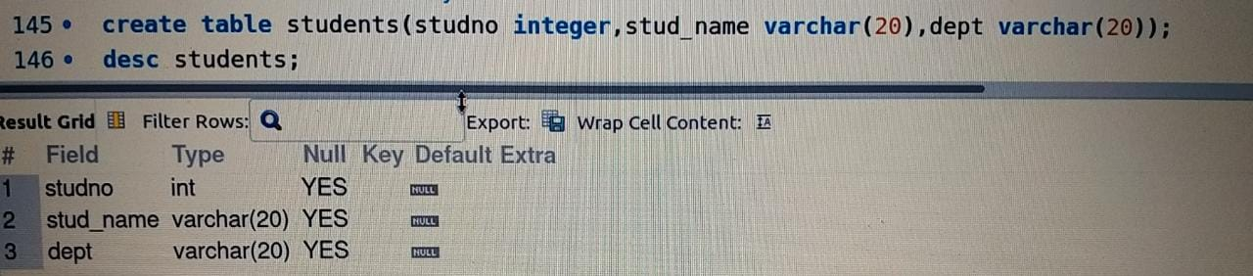
Create view and select
Insert values
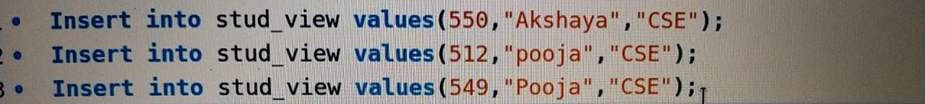
Create view with check option

Insert values and alter table.
